ST. XAVIER’S COLLEGE

**(Affiliated to Tribhuvan University)**

**Maitighar,Kathmandu**



**Computer Graphics**

**Lab Assignment #4**

**Submitted By**

Ajita Khatiwada

B.Sc. CSIT

Year II/IV Semester

013BSCIT004

**Submitted To:**

Er. Anil Kumar Sah

Lecturer,

Department of Computer Science

St. Xavier’s College

Maitighar, Kathmandu

**Submitted On:**

18th August , 2015

**STATEMENT: Implement BLA line drawing algorithm in C++ builder**

**ALGORITHM:**

1. Input the two line endpoints and the left endpoint at (x0,y0)
2. Load (x0,y0) into frame buffer, i.e. plot the first point.
3. Calculate constants 2∆x, 2∆y and obtain first decision parameter p0 = 2∆y – ∆x
4. At each xk along the line, starting at k = 0, perform the following test,

If pk < 0, next point is (xk+1,yk) and pk+1 = pk + 2∆y

Otherwise, next point to plot is (xk+1,yk+1) and pk+1 = pk + 2∆y – 2∆x

1. Repeat step 4 ∆x times.

**SOURCE CODES** :

//---------------------------------------------------------------------------

#include <vcl\vcl.h>

#pragma hdrstop

#include "bla.h"

//---------------------------------------------------------------------------

#pragma resource "*.dfm"

TForm1 *Form1;

int x1,x2,y1,y2;

//---------------------------------------------------------------------------

__fastcall TForm1::TForm1(TComponent* Owner)

: TForm(Owner)

{

}

//---------------------------------------------------------------------------

void __fastcall TForm1::Edit1Change(TObject *Sender)

{

x1=StrToInt(Edit1->Text);

}

//---------------------------------------------------------------------------

void __fastcall TForm1::Edit2Change(TObject *Sender)

{

y1=StrToInt(Edit2->Text);

}

//---------------------------------------------------------------------------

void __fastcall TForm1::Edit3Change(TObject *Sender)

{

x2=StrToInt(Edit3->Text);

}

//---------------------------------------------------------------------------

void __fastcall TForm1::Edit4Change(TObject *Sender)

{

y2=StrToInt(Edit4->Text);

}

//---------------------------------------------------------------------------

void __fastcall TForm1::Button1Click(TObject *Sender)

{

int x, y, dx, dy, pk, k, xEnd;

dx=abs(x2-x1);

dy=abs(y2-y1);

if(x1>x2)

{

x = x2;

y = y2;

xEnd = x1;

}

else

{

x = x1;

y = y1;

xEnd = x2;

}

Image1->Canvas->Pixels[x][y] = RGB(0,0,255);;

pk=2*dy-dx;

while (x<=xEnd)

{

if(pk<0)

{

x=x+1;

y=y;

pk=pk+2*dy;

}

else

{

x=x+1;

y=y+1;

pk= pk+2*dy-2*dx;

}

Image1->Canvas->Pixels[x][y] = RGB(10,10,0);

}

}

**OUTPUT :**

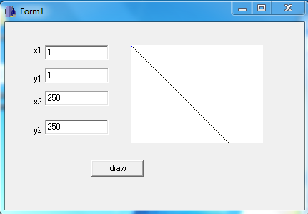

**CONCLUSION** :

Hence , BLA algorithm was used to draw the line using c++builder.